**CN Assignment 6**

Name: Erwin Wu

Affiliation: Koike Lab

Student ID: 17M38147

**Application of Complex Networks**

The class held on Jan.29th summarized about Complex Social Networks and the class on Feb.1st introduced some application of complex networks. I got quite a few inspirations about complex network from the class.

My major research is about deep learning, so, I’m thinking of applying it to Social Networks. For example, the link prediction problem has always been popular among social networks research. Link prediction is to forecast the development (or we can say the trend) of the relationship between nodes with the existed network. It’s quite important in social network because we can predict one person’s social intercourse or even his behavior and his role in the society. Many research about link prediction has been done and several methods have been used, while among them deep learning-based link prediction might be a best solution for social network forecasting.

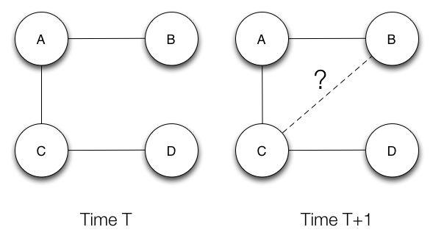

Fig 2. Link prediction [1]

As we learnt before, social networks are highly dynamic objects which grow and change quickly over time through the addition of new edges, signifying the appearance of new interactions in the underlying social structure. There are some previous research dealing with link prediction by link-based methods[2], however they almost account only for the link structures of networks and ignore the node attributes which are in face also useful for link prediction. On the other hand, deep neural network is possible to learn the features of attributes and the changes of them on time sequence. (For example, the LSTM model [3]). I believe by jointly modeling the node attributes and link structures, link prediction can get the best of both worlds and deliver state-of-the-art performance for Social Network.

Though I still not have a detailed design, but I believe unsurprised DBN (Deep Belief Network) based prediction method (like Restricted Boltzmann Machine ) can be a solution to represent features for link prediction. I’ll try to use these ideas for my further research, therefore, I appreciate the professors given lectures about complex network to us, it means a lot to me.

‘

[1] Organizational Overlap on Social Networks and its Applications [2018-02-03]: <https://engineering.linkedin.com/social-network-analysis/organizational-overlap-social-networks-and-its-applications>

[2] Hunter, D.; Smyth, P.; Vu, D. Q.; and Asuncion, A. U. 2011.Dynamic egocentric models for citation networks. In ICML,857–864.

[3] Understanding LSTM Networks [2018-02-03]: http://colah.github.io/posts/2015-08-Understanding-LSTMs/

[4] Six degrees of separation, <https://en.wikipedia.org/wiki/Six_degrees_of_separation>